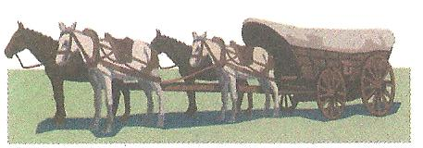
Wellsville Frontier Day, Inc.

MEMBERSHIP APPLICATION

Date: _____/______/______

Name: ________________________________________________________Birth Date ___/___/_______
Spouse Name: __________________________________________________Birth Date ____/____/______
Address: _________________________________________________________________________________
City: ___________________________________ State: ________ Zip Code: _________-__________
Home Phone: (____) ______ -____________ Cell Phone: (____) ______ -____________
E-Mail Address: ____________________________________________________________________________

Children Name(s) Under 19 Age Birth Date
_____________________________________________________ _____ _____/______/______
_____________________________________________________ _____ _____/______/______
_____________________________________________________ _____ _____/______/______
_____________________________________________________ _____ _____/______/______
_____________________________________________________ _____ _____/______/______
_____________________________________________________ _____ _____/______/______

MEMBERSHIP FEES

Family Membership
Initiation Fee $35.00 (first year only)
Yearly Dues $35.00 (due by March 1st of each year)
Total Due upon Application $70.00

Single Membership
Initiation Fee $25.00 (first year only)
Yearly Dues $25.00 (due by March 1st of each year)
Total Due upon Application $50.00

Make Checks Payable To: Wellsville Frontier Days, Inc.

Applicant Signature: ________________________________________________________________________
Sponsors Signature: _________________________________________________________________________
(Active Club Member Only)

Note: Sponsor and Applicant must be present at meeting when application is presented to General Membership along with the appropriate initiation fee. Applicant must attend the general meeting two (2) months after submitting the application to be voted into the club by General Membership.

