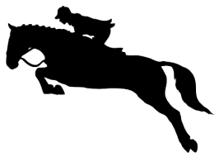
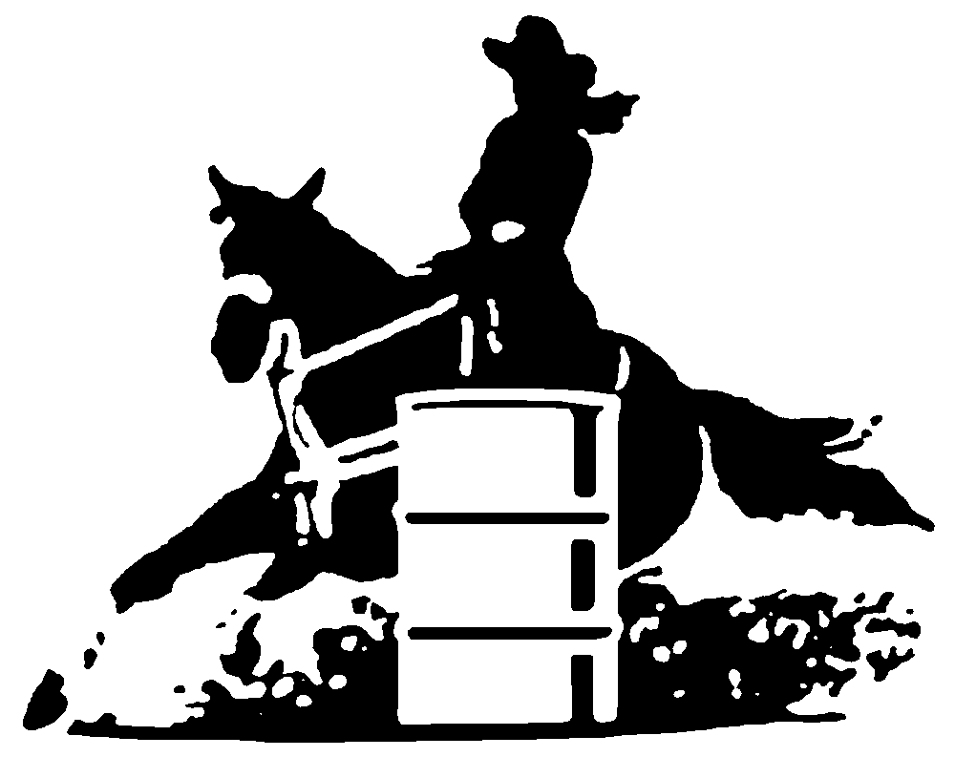
WFD Youth Show
(18 and Under)
1621 Lisburn Rd, Wellsville, PA 17365
September 10, 2022 Rain or Shine
9:00 a.m. (schooling 7:45-8:45 a.m.)
Cost $50 for the day or $6 per class
Judge: Morgan Wagner
Call (717) 515-9943 for more information

Lead-line English/ Western (7 &Under)
- Lead-line Walk
- Lead-line W/T
- Off Lead-line Walk

English Junior Riders (12 & Under)
- English Pleasure
- English Equitation
- Hunter Hack (cross rails or 18”)
- Cross Rails (4)
English Senior Riders (13 & Over)
- English Pleasure
- English Equitation
- Hunter Hack (18” or 2’)
- Cross Rails (8)
Western Junior Riders (12 & Under)
- Western Pleasure
- Western Equitation
- Ranch Riding (pattern)
- Ranch Horse Pleasure
Western Senior Riders (13 & Over)
- Western Pleasure
- Western Equitation
- Ranch Riding (pattern)
- Ranch Horse Pleasure

- Pleasure Pairs (English or Western)
- OPEN Egg and Spoon (any age rider)

Peewee / Lead-line Gaming (7 &Under)
**The runner MUST stay behind the horse’s nose when crossing the timers. Times will NOT count if the runner crosses the timers first**
- Poles
- Barrels
- 50 Yard Dash
- Keyhole
Gaming Junior Riders (12 & Under)
- Poles
- Barrels
- 50 Yard Dash
- Keyhole
Gaming Senior Riders(13 & Over)
- Poles
- Barrels
- 50 Yard Dash
- Keyhole

Attire: English and Western Casual
** polo or button down shirts (short sleeve permitted), breeches/jeans, boots, helmet. No T-shirts, hoodies, shorts or sneakers. You may be disqualified for improper attire.

** NO FOOD stand – please bring your own food and drinks **

Rider Name:_____________________________Horse Name:____________________________

Age (as of 1/1/2022): ___________ Back Number:_________Total Amount Paid:__________

Rules: If you are 18 years of age or under as of 1/1/2022 you are eligible to participate in the Youth Show. Cost is $50 for the day (per rider/horse combo – may only enter one age division) or $6 per class. Ribbons will be awarded 1st thru 6th place for each class. Decision of the judge and show committee is final. Helmets are required.

Release statement: I release Wellsville Frontier Days Inc., their insurance company and their volunteers of any liability from accident, injury or any contractible illness (including Covid-19) to horse, personal property, or rider/myself while a contestant or spectator during this event.

SIGNATURE __________________________________________________________(Parent/Guardian Signature if under age 18)

